*To*

*Human Resource Department*

**Subject: Seeking for a Position in HRM**

I am a self –motivated person with various competencies regarding to Human Resources department, holding responsibilities such as following:

* Maintaining employee’s personal files and records,
* Designed various HR policies and conducted induction program,
* Tracking attendance, Maintaining leave records, Pf records, issue letters,
* Generation of Experience Letters, Relieving Letters.
* Statutory and other deductions from the salary, settling employees’ grievances as regards to salary, monthly payroll for approximately 300 employees, disbursing wages for contract labour employees through bank.
* Training, development and supervision of new employees.

**For this purpose, I would like to inform you that I have the willingness and fully prepared to work in your progressive organization**.

*I would be grateful if you would keep my CV for any future possibilities.*

*Looking forward to present myself in the interview*

*Yours respectfully,*

***SHAILAJA DALVI***

+973 – 33026540 – 39934250

shailaja_dalvi@yahoo.co.in

Manama – Kingdom of Bahrain

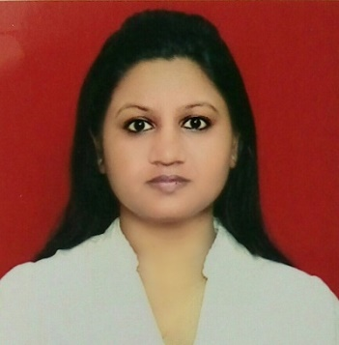

**SHAILAJA DALVI**

HR Administrator

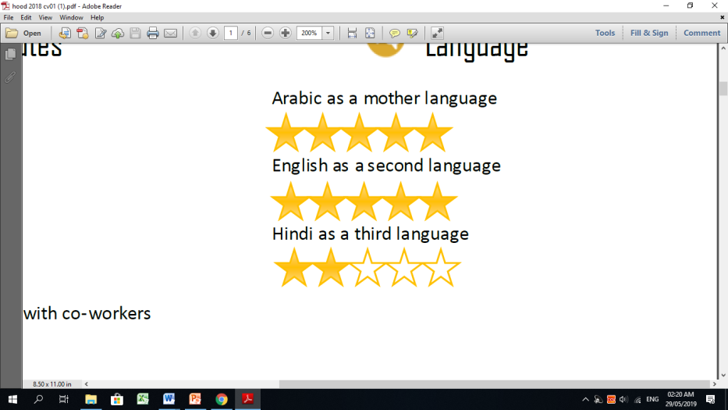LANGUGEC

CONTACT

+973 – 33026540 – 39934250

[shailaja_dalvi@yahoo.co.in](mailto:shailaja_dalvi@yahoo.co.in)

Manama – Bahrain Kingdom

|  |
| --- |
|  |
|  |
|  |
|  |
|  |
|  |
|  |
|  |

CONTACT

973 – 38179277

Hood23abuhasan@gmail.com

Manama – Bahrain Kingdom



**EDUCATION**

**Post Graduate Diploma in Labour Laws**

2017 - D.Y.PATIL LAW College, Pimpri, Pune

**M.B.A (HR)**

2010 - NIMS, Chinchwad, Pune

**Post Graduate Diploma in Foreign Trade**

2008 - IBMR, Chinchwad Pune

**B.Sc. (Biotech)**

2007 - D.Y.PATIL ACS College, Pimpri, Pune

**Higher Secondary Certificate**

2004 - Abasaheb Garware College, Pune

**Secondary School Certificate**

2002 - St. Ursula High School, Akurdi, Pune

**COMPUTER LITERACY**

Working knowledge of Microsoft Word, Excel, Advance Excel and Power-point,

MS-CIT

LANGUAGE

**Hindi** as a mother language



**English** as a second language



|  |
| --- |
| OBJECTIVE |
| To perform my level best for the success and growth of the organization and to learn as well as gain knowledge in my field. |
| EXPERIENCE |
| **KELVION INDIA PVT LTD**  Designation : Manager- HR & Admin  Location : Pune.  Duration : 26th Nov-2015 to 20th Apr-2019 |
| **SHREE SADGURU ENTERPRISES**  Designation : Asst.Manager- HR & Admin  Location : Pune.  Duration : 25th May 2011 to 15th Oct 2015  **WIPRO LTD**  Designation : Senior HR Associate  Location : Pune  Duration : 9th Aug 2007 to 14th April 2011   |  | | --- | | SKILLS |  * Excellent communication and multi-tasking skills * Empathetic skills and the ability to maintain interpersonal relations * Positive work ethic. * Confident, Flexible in work * Good analytical and presentation skills. * Quick grasping power and decision making ability.   Related image |

**TRAINING ATTENDED**

* Technical skills development training.
* Advanced Interpersonal Communication sessions.
* Training on soft skills and personality development

**EXTRACURRICULAR ACTIVITY**

* Participated in competitions like Chess, Swimming, Badminton, Quiz at inter- school, inter-college and District levels
* Was awarded with Mrs.Shirinbai Tapi Memorial Prize.
* Won several prizes in essay competitions at school and graduation levels.
* Undertook study tours to places like National Chemical Laboratory (Pune), NARI, Vasantdada Sugar institute.

**HOBBIES**



**PERSONNEL INFORMATION**

**Date of birth:** 08/12/1985

**Marital Status:**  Married

**Sex:** Female.

**Passport no**: Z5121441

**Nationality :** Indian

**CPR No**. 851272088

***Declaration:***

I hereby declare that the above mentioned information is true to the best of my knowledge and belief.

SHAILAJA DALVI